A Full Caterpillar Robotic Vehicle Design

Dequn Teng

University of Liverpool, England Email: [D.Teng@student.liverpool.ac.uk](mailto:D.Teng@student.liverpool.ac.uk)

***Abstract*—Modern warship requires the combination of robotics systems to cooperate in winning the war. However, modern armored vehicles are following traditional car styling, with the main point of fire is in front. However, both flanks of the armored vehicle are vulnerable to attack since it is hard to change the orientation of the barrel. Current literature mainly covers soft robotics, Full-tracked armored vehicle facing the front. However, there is a gap in designing robotics systems focusing on flanking firepower and corresponding coordination.**

**Therefore, This paper discusses a Full-Caterpillar Robotic Vehicle Design, including a carriage, the engine of which is bolted to the center at both sides of the bottom of the interior cavity of the carriage, the output shaft of which is bolted to first gear, the bearings embedded in both sides of the front and back of the interior cavity of the carriage, and the inner ring of which is rotatingly connected with a rotating shaft. The invention improves the driving force through the two engines, so that the armored car can reach the battlefield more quickly and sensitively to annihilate the enemy, improves the annihilating power of the armoured car by equipping the flame thrower, speeds up the annihilation speed of the enemy, facilitates the identification and locking of the armoured car to the enemy through the cooperation of the camera and the infrared sensor camera, improves the speed of annihilation of the enemy through the flame thrower, and speeds up the annihilation speed of the enemy through the flame thrower along the carriage. The top axis is symmetrically distributed, which makes it easy for the armoured vehicles to destroy the enemies in the front and rear directions at the same time, increasing the speed of the armoured vehicles in destroying the enemies and solving the problem of the traditional Fire Centipede armoured vehicles being slow in destroying the enemies.**

**Keywords: Robotics, Locomotion, Fill-Caterpillar, Automa- tion.**

1. INTRODUCTION

The armoured car is a variety of tracked or wheeled military vehicles with armoured protection, is a general term for military or police vehicles equipped with armour, the tank is also a kind of armoured vehicle tracked armoured vehicles, but in the customary use of combat usually due to another independent classification, and the armoured vehicle mostly refers to the protective force and firepower than the tank’s weak vehicle types [1], [2], [3].

In some urban street battle battlefields, due to the complex terrain, the enemy needs to be annihilated with the help of Fire Centipede armoured vehicles. However, the traditional Fire Centipede armoured vehicles are slow to annihilate the enemy’s living force, making it easy for the enemy to seize the opportunity to strike back at us, which is not conducive to our control of the battlefield and ultimately leads to our defeat [4], [5].

1. LITERATURE REVIEW

Previously researchers have been introducing the ”low- cost worm-shape robot that can mimic the locomotion of a caterpillar to crawl” [6]. However, the corresponding moving efficiency and speed are not suitable for large scale deployment and implementations. Additionally, Kim also introduces Soft robotics with inspirations from brain structure [7]. It has unique characteristics to the new area of robotics engineering, however, the corresponding efficiency is not as beneficial as expected. Moreover, Pavlo introduces a Mobile robotic vehicle which is patented in the US. However, it is still following the traditional tank design, rather the firepower in conjunction with the other armed fire powers [8]. What is more, Oyejide introduces the sensor-controlled Cart-Trolley, which serves to be the precursors for applying sensor and embedded system technologies in influencing creating the more productive tools [9]. Moreover, in the area of space emergency, an omnidirec- tional unmanned ground vehicle was introduced by Lingfei and Tiansheng with the capability in rescue missions. However, it is still holding on to the traditional vehicle moving pattern, ignoring the unique characteristics involved in the warship environment [10]. In the area of mobility and trajectory, a positioning and trajectory tracking approach was introduced for Caterpillar Vehicles in Unknown Environment by Van Lanh Nguyen and his colleagues with the emphasis on the SLAM and Computer Vision based on camera calibration techniques [11], [12] [13], [14]. In the area of military, robotic autonomous systems have played an essential role in earthmoving introduced by Haa, Yenb, and Balaguerc [15]. Besides, in the area of Bionanotechnology, Lopez-Arreguin and Montenegro introduced bio-inspired robots for under- ground and surface exploration which serves to be inspiring for designing robotics under a warship environment full of uncertainty [16].

1. METHODOLOGY
2. *Specifications*

The purpose of the present design is to provide a Fire Centipede armoured vehicle to solve the problem raised in the above background technology.

To achieve the above purpose, the design provides the following technical solution: a fire centipede armoured vehicle comprising a carriage, said carriage having an engine bolted to the centre at the bottom of both sides of the interior cavity, said engine having an output shaft bolted to first gear, said carriage having bearings embedded on both the front and back sides

of the interior cavity and a rotating shaft rotatingly connected to the inner ring of the bearings, said surface of the rotating shaft bolted to second gear, said second gear meshing with the opposite side of the first gear, said front and back sides of the rotating shaft running through the carriage and bolted to an active wheel, said surface of the active wheel being connected by a track drive [17].

Preferably, the inner cavity of the compartment is fixedly connected with a fuel tank from left to right, and a fuel outlet pipe is connected at the centre of the front and back of the fuel tank, and an end of the fuel outlet pipe away from the fuel tank runs through the compartment and is connected with a flame thrower, and the opposite side of the flame thrower is bolted to the front and back of the compartment, and the top of the front of the compartment is connected with an oil inlet from left to right.

Preferably, the communication module is bolted to both sides at the bottom of the interior cavity of the compartment, and the communication mode of the communication module uses a military communication band for communication.

Preferably, the processor is bolted to the front on both sides of the bottom of the interior cavity of said compartment, and the surface on both sides of the bottom of the interior cavity of the said compartment is bolted to the ESC.

Preferably, said front and back sides of the compartment are bolted to a camera and said front and back sides of the compartment are bolted to an infrared sensing camera.

Preferably, said the number of flamethrowers is not less than eight, said flamethrowers being divided into two groups and symmetrically distributed along the central axis of the top of the compartment.

Preferably, said fuel tank is embedded with a fuel sensor at the centre of the bottom of the inner cavity, and the distribution of said fuel tank is in the form of independent distribution, and the number of said fuel tanks is half of the number of flamethrowers [18].

The beneficial effects of this design compared to the prior art are.

This design enhances the mobility of the armoured vehicle by increasing the driving force through two engines, which makes the armoured vehicle reach the battlefield faster and more sensitive to annihilate the enemy; by equipping the flame thrower, it enhances the annihilating firepower of the armoured vehicle and speeds up the speed of annihilating the enemy; through the cooperation of the camera and infrared sensor camera [19], it facilitates the armoured vehicle to identify and lock on the enemy and enhances the annihilation of the enemy by the flame thrower. The flame throwers are symmetrically distributed along the central axis on the top of the carriage, which makes it easy for the armoured vehicles to destroy the enemy in the front and rear directions at the same time, and improves the speed of the armoured vehicles to destroy the enemy, solving the problem of the slow speed of the traditional fire centipede armoured vehicles to destroy the enemy.

The design enhances the firepower of the armoured vehicle through the cooperation of fuel tank and flame thrower [20],

[18], which is convenient for the armoured vehicle to anni- hilate the enemy and enhances the security of our military deployment signal through the communication module using military communication band to prevent the enemy from monitoring our signal information and destroying our military force [21]. The signal emitted improves the reaction speed of the armoured car, facilitates the armoured car to identify and locate the enemy through the cooperation of camera and infrared sensor camera, enhances the speed of the armoured car to destroy the enemy [22], facilitates the armoured car to destroy the enemy in the front and rear direction simultane- ously through the number of flamethrowers not less than eight and symmetrical distribution along the central axis of the top of the car, enhances the speed of the armoured car to destroy the enemy through the fuel quantity [23]. With the cooperation of the sensor, it can monitor the remaining fuel level in the fuel tank, which is convenient for deploying the armoured vehicle to annihilate the enemy or retreat, and ensures the maximum safety of the armoured vehicle [24].

1. *Description of the attached diagram*

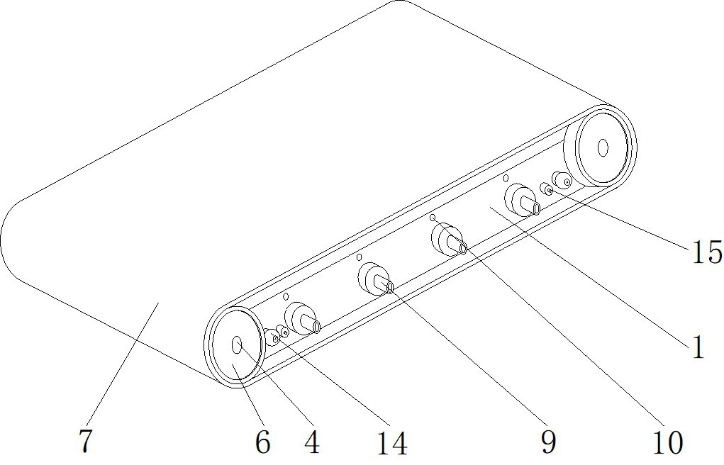

Fig. 1: Vehicle Schematic Diagram

Figure 1 shows a schematic diagram of the structure of a better embodiment of the Fire Centipede armored vehicle provided by the design.

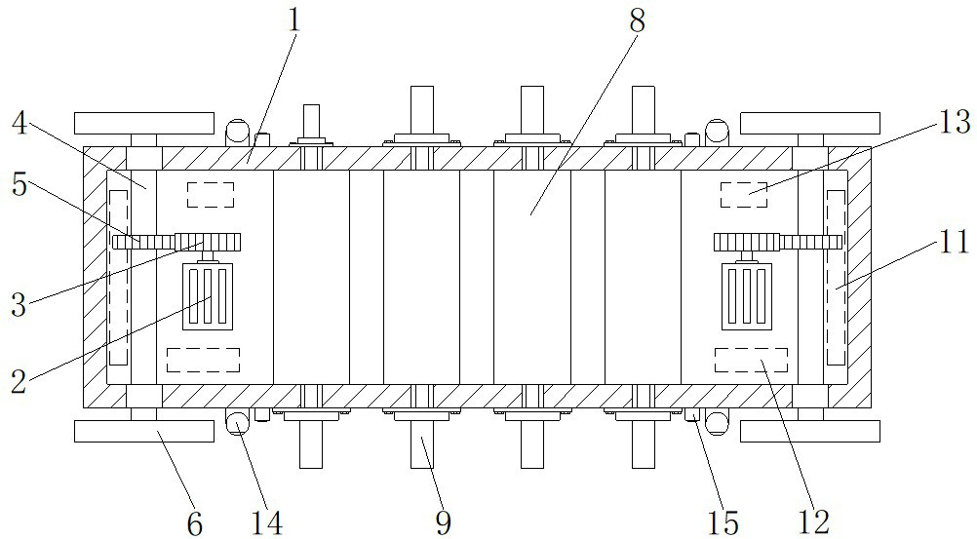

Fig. 2: Vehicle Top View Section

Figure 2 shows a top view section of the structure of the Fire Centipede armored vehicle shown in Figure 1.

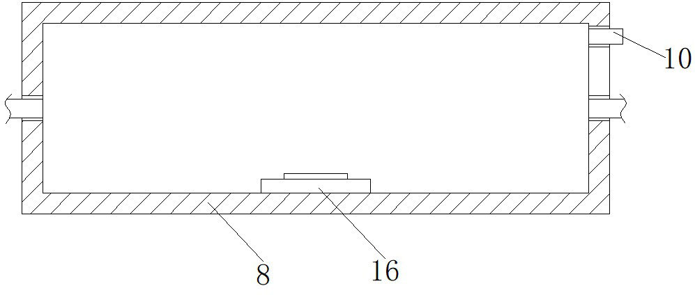

Fig. 3: Vehicle Left-view Section

Figure 3 shows a left-view section of the structure of the fuel tank shown in Figure 1.

In the figure: 1, compartment; 2, engine; 3, first gear; 4,

rotating shaft; 5, second gear; 6, active wheel; 7, track; 8,

fuel tank; 9, flamethrower; 10, oil inlet; 11, communication

module; 12, processor; 13, ESC[25]; 14, camera; 15, infrared sensing camera; 16, fuel sensor.

1. IMPLEMENTATION

The following is a clear and complete description of the technical scheme in the present design example in conjunction with the drawings in the present design example, and it is obvious that the described example is only a part of the present design example, but not all of the examples. Based on the embodiments of the present design, all other embodiments obtained by ordinary persons of skill in the art without performing creative work are within the scope of protection of the present design.

In the description of the present design, it should be noted that the terms ”above,” ”below,” ”inside,” ”outside” ”front end”, ”back end”, ”both ends”, ”one end”, ” The orientation or position relationship indicated by ”other end”, etc., is based on that shown in the drawings and is intended only to facilitate and simplify the description of the design, and is not intended to indicate or imply that the devices or components referred to must have a particular orientation, be constructed and operate in a particular orientation, and therefore is not to be construed as a limitation of the design. Furthermore, the terms ”first” and ”second” are used for descriptive purposes only and are not to be understood as indicating or implying relative importance.

In the description of this design, it should be noted that, unless otherwise specified or limited, the terms ”installed”, ”set up”, ”connected”, etc., are to be understood in a broad sense, for example. ”Connection”, which may be a fixed or removable connection or an integral connection; which may be mechanical or electrical; which may be direct or indirect through an intermediate medium; and which may be a connection within two components. Those of ordinary skill in the art will understand the specific meaning of the above terms in this design on a case-by-case basis.

Referring to FIGS. 1-3, the present design provides an embodiment: a fire centipede armoured vehicle, including a compartment 1, an engine 2 bolted to the centre at both sides of the bottom of the compartment one inner cavity, a first gear 3 bolted to the output shaft of the engine 2, a bearing

embedded in the front and back sides of the compartment one inner cavity, and a rotating shaft four rotating in the inner ring of the bearing, second gear 5 bolted to the surface of the rotating shaft 4, and the second gear 5 bolted to the surface of the rotating shaft 4, and second gear 5 bolted to the inner ring of the bearing. The front and back of the rotating shaft four run through the compartment one and are bolted to the active wheel 6, the surface of the active wheel six is connected by the track seven drive, which increases the driving force through the two engines 2, enhances the mobility of the armoured car and makes the armoured car reach the battlefield faster and more sensitive to annihilate the enemy, by equipping the flamethrower 9, it improves the armoured car’s annihilating firepower and accelerates the speed of the enemy. Through the cooperation of camera 14 and infrared sensor camera 15, it is easy for the armoured car to identify and lock on the enemy, which improves the speed of annihilating the enemy of flame thrower 9. Through the symmetrical distribution of flame thrower nine along the centre axis of the top of compartment 1, it is easy for the armoured car to annihilate the enemy in the front and rear direction at the same time, which improves the speed of annihilating the enemy of the armoured car and solves the slow speed problem of annihilating the enemy of the traditional fire centipede armoured car.

The inner cavity of compartment one is fixedly connected with fuel tank eight from left to right, and a fuel outlet pipe is connected at the centre of the front and back of the fuel tank 8, and the end of the fuel outlet pipe away from the fuel tank 8 runs through compartment one and is connected with flame thrower 9, and the opposite side of flame thrower nine is bolted to the front and back of compartment 1, and the top of the front of compartment one is connected with fuel inlet ten from left to right, which enhances the firepower of the armoured vehicle and facilitates the annihilation of the enemy by the cooperation of fuel tank eight and flame thrower 9.

The communication module 11 is bolted on both sides of the bottom of the inner cavity of the carriage 1, and the communication module 11 adopts military communication fre- quency band for communication, which enhances the security of our military deployment signal and prevents the enemy from monitoring our signal information and destroying our military force.

The processor 12 is bolted to the front on both sides of the bottom of the inner cavity of compartment 1, and the ESC 13 is bolted to the surface on both sides of the bottom of the inner cavity of compartment 1. The cooperation between the processor 12 and the ESC 13 facilitates the armoured vehicle to quickly process the signals sent by the commanding officer and improves the response speed of the armoured vehicle.

Both sides of the front and back of the compartment one are bolted to the camera 14, and both sides of the front and back of the compartment one are bolted to the infrared sensor camera 15, through the cooperation of the camera 14 and the infrared sensor camera 15, it is convenient for the armoured car to identify and locate the enemy, and improve the speed of the armoured car to annihilate the enemy.

The number of flamethrowers 9 is not less than eight, and the flamethrowers nine are divided into two groups and symmetrically distributed along the middle axis of the top of the compartment 1. Through the number of flamethrowers, nine is not less than eight and symmetrically distributed along the middle axis of the top of the compartment 1, it is easy for the armoured car to destroy the enemy in the front and rear direction at the same time, and enhance the speed of the armoured car to destroy the enemy.

The oil sensor 16 is embedded in the centre of the bottom of the inner cavity of the oil tank 8, and the distribution of the oil tank eight are independently distributed, and the quantity of the oil tank 8 is half of the quantity of the flamethrower 9, with the cooperation of the oil sensor 16, the remaining oil quantity of the oil tank eight can be monitored, which is easy to deploy the armoured car to annihilate the enemy or retreat and guarantee the safety of the armoured car to the maximum extent.

Working principle: When operating, the commander sends a signal through the controller, then the communication module

11 sends the received signal to the processor 12, at the same time the processor 12 processes the received signal and transmits the processed information to the ESC 13, then the ESC 13 sends a signal to the engine 2, then the engine two does work to open, at the same time the output shaft of the engine 2 drives the first gear 3 to rotate, then the first gear 3 to rotate, then the first gear 3 to rotate. Gear 3 drives the second gear 5, while the second gear 5 drives the rotating shaft 4, which then drives the active wheel 6, at which point the armoured vehicle enters the urban street fighting battlefield, and then the camera 14 and infrared sensor camera 15 monitor the battlefield, while the camera 14 and infrared sensor camera 15 identify and locate the enemy, and then the camera 14 and infrared sensor camera 15 transmit the information to the processor 12, which then controls the flamethrower 9 to emit flame for rapid annihilation of the enemy.

It will be apparent to those skilled in the art that the present design is not limited to the details of the exemplary embodiment described above, and that it is capable of being implemented in other specific forms without departing from the spirit or essential features of the present design. Thus, in every respect, the examples are to be regarded as exemplary and non-limiting, and the scope of the design is limited by the appended claims rather than by the foregoing description and is therefore intended to encompass all variations falling within the meaning and scope of the equivalent elements of the claims. None of the figure marks in the claims should be regarded as limiting the claims to which they refer.

1. EVALUATION AND DISCUSSION

A new age urban street fighting tracked vehicle to quickly eliminate enemy forces: the Fire Centipede. This flame-tracked vehicle is intended for use in urban street battles, where the opponent uses guerrilla tactics and we use scorched-earth tactics. The vehicle’s use strategy is to set the maximum distance the vehicle can travel and the distance it can return,

start the vehicle, and execute scorched earth tactics[26]. The vehicle is equipped with a vehicle-mounted camera, which can provide information about the status of the battlefield and allow the remote control personnel to control the flame spray according to the actual situation on the battlefield. The vehicle is equipped with a depth camera, based on the depth of field algorithm to calculate the distance to the target, control the flame spray distance to achieve the destruction of targets.

Based on communication module: use 2.4G or 5.8G or mili- tary communication band to communicate [27], processor stem 32 [28] (should be near the attachment of the communication module): the user processes the instructions issued by the commander, if you want to add a deep learning platform, you can use TX2 or NVIDIA nano[29], [30], ESC: the instructions received from the processor can be converted into instructions that the engine can understand, the fuel tank provides the flame thrower with Energy, flamethrower, destroys the opponent’s living force, can be started with a motor or a conventional fuel engine. The engine, receives commands from the processor to spin.

Altering the car provides two methods of attack: 1. Control of the associated flamethrower via a remote sensing module;

2. Designing the object to be identified at the start, e.g. (with a living organism), pattern recognition via the onboard depth camera and infrared sensing camera, and if successful, attack. The vehicle provides two return modes: 1. remote return;

2. designing an automatic return path via a fuel sensor or a power sensor.

In short, we offer that a full tracked vehicle is available and can greatly increase the dominance of the battlefield.

1. FUTURE WORK

The future work mainly lay on the following three aspects, which are future specifications, more simulation modelings, and more prototype verification.

1. *Detailed Specifications*

Currently, we are only introducing a basic framework for the corresponding robotic vehicle design. However, there are not too many descriptions about which materials should be applied to which sections in utilizing the best possible efforts for the overall performance of this full caterpillar robotic vehicle design. Further knowledge gap should be fulfilled with more domain-specific knowledge in material science to material in the comprehensive demonstration.

1. *Simulation Modelings*

With more theoretical verifications and detailed specifi- cations, it is laid a solid foundation for the corresponding simulation such as the Gazebo, which is fully adapted to the Robotic Operating System (ROS) [31]. Based on the ordinary differential equation (ODE) described in the physics engine, it is easy to model the corresponding kinetic and dynamic characteristics of the system, which is for future implementation reference.

1. *Prototype Verification*

Along with the development of electronic engineering, such as the printed circuit board toolkit, together with the embedded system design such as Raspberry and Arduino. It is much easier to verify the ideas from scratch as a DIY project. For example, NVIDIA introduces the platform for the self navigational Autopilot car based on the Jetson Nano platform and the 3D printing toolkits with the CAD files open-source on the public [32].

1. *Cooperation between chariots*

Since this design focuses on flanking firepower, the future design in collaboration between conventional artillery with this artillery could be modeled using Metacellular automata and Graph Theory Algorithm.

1. CONCLUSION

Therefore, this paper introduces a Full-Caterpillar Robotic Vehicle Design with the functionality for quickly and inten- sively shooting and firing the objects within the target area, with the low cost and low human interference with the help of the remote control techniques. Compared with the traditional tank or armoured car, where there is only one or two limited fire output, this design is providing nearly eight times the firing capability in significantly improving the firing intensity for controlling the dominance in the war. Additionally, in facing the challenges from the missiles from the sky, especially unmanned aerial vehicle (UAV), we have introduced the Anti- missile armor in preventing the design for a limited number of missiles. However, if there are abundant of missiles attacking, this vehicle is hard to survive, serving to be the limitation of this design. In the future, possibly, it is possible to introduce more missile detection approaches to automatically avoid or fight against the approach for future improvements.

1. ACKNOWLEDGEMENT

Thanks to the research administration office (RAO) at Xi’an Jiaotong-Liverpool University for supporting the writing of this paper in robotics and Locomotion, especially Prof. Dechang Xu as the director of RAO, and also my sincere supervisor for providing invaluable suggestions in making me a better student [33].

REFERENCES

1. S. J. Henderson and S. Feiner, “Evaluating the benefits of augmented reality for task localization in maintenance of an armored personnel carrier turret,” in *2009 8th IEEE International Symposium on Mixed and Augmented Reality*. IEEE, 2009, pp. 135–144.
2. J. Jackowski and R. Wantoch-Rekowski, “Classification of wheeled mil- itary vehicles using neural networks,” in *18th International Conference on Systems Engineering (ICSEng’05)*. IEEE, 2005, pp. 212–217.
3. A. H. Hosseinloo, N. Vahdati, and F. F. Yap, “Performance of spade- less wheeled military vehicles with passive and semi-active suspensions during mortar firing,” *Vehicle system dynamics*, vol. 50, no. 10, pp. 1515– 1537, 2012.
4. M. Windrow, *The Last Valley: Dien Bien Phu and the French Defeat in Vietnam*. Hachette UK, 2011.
5. J. De Leo´n, *The land of open graves: Living and dying on the migrant trail*. Univ of California Press, 2015, vol. 36.
6. L. Liao, G. Liao, Y. Lin, C. Huang, and Y. Tsai, “Design and imple- mentation of a caterpillar robot,” in *2018 9th International Conference on Awareness Science and Technology (iCAST)*, 2018, pp. 1–5.
7. S. Kim, C. Laschi, and B. Trimmer, “Soft robotics: a bioinspired evolution in robotics,” *Trends in Biotechnology*, vol. 31, no. 5, pp. 287 – 294, 2013. [Online]. Available: <http://www.sciencedirect.com/science/article/pii/S0167779913000632>
8. “Us7926598b2 - mobile robotic vehicle - google patents,” https://patents.google.com/patent/US7926598B2/en, (Accessed on 12/23/2020).
9. O. Oyejide, M. Okwu, L. Tartibu, and O. Olayode, “Development of sensor controlled convertible cart-trolley,” *Procedia CIRP*, vol. 91, pp. 71 – 79, 2020, enhancing design through the 4th Industrial Revolution Thinking. [Online]. Available: <http://www.sciencedirect.com/science/article/pii/S2212827120307873>
10. L. Qi, T. Zhang, K. Xu, H. Pan, Z. Zhang, and Y. Yuan, “A novel terrain adaptive omni-directional unmanned ground vehicle for underground space emergency: Design, modeling and tests,” *Sustainable Cities and Society*, vol. 65, p. 102621, 2021. [Online]. Available: <http://www.sciencedirect.com/science/article/pii/S2210670720308386>
11. L. Zhou, G. Wang, K. Sun, and X. Li, “Trajectory tracking study of track vehicles based on model predictive control,” *Strojnisˇki vestnik - Journal of Mechanical Engineering*, vol. 65, pp. 329–342, 06 2019.
12. G. Grisetti, R. Kummerle, C. Stachniss, and W. Burgard, “A tutorial on graph-based slam,” *IEEE Intelligent Transportation Systems Magazine*, vol. 2, no. 4, pp. 31–43, 2010.
13. O. Russakovsky, J. Deng, H. Su, J. Krause, S. Satheesh, S. Ma,

Z. Huang, A. Karpathy, A. Khosla, M. S. Bernstein *et al.*, “Imagenet large scale visual recognition challenge,” *International Journal of Com- puter Vision*, vol. 115, no. 3, pp. 211–252, 2015.

1. Z. Zhang, “A flexible new technique for camera calibration,” *IEEE Transactions on Pattern Analysis and Machine Intelligence*, vol. 22, no. 11, pp. 1330–1334, 2000.
2. Q. Ha, L. Yen, and C. Balaguer, “Robotic autonomous systems for earthmoving in military applications,” *Automation in Construction*, vol. 107, p. 102934, 2019. [Online]. Available: <http://www.sciencedirect.com/science/article/pii/S0926580518309932>
3. A. Lopez-Arreguin and S. Montenegro, “Towards bio-inspired robots for underground and surface exploration in planetary environments: An overview and novel developments inspired in sand-swimmers,” *Heliyon*, vol. 6, no. 6, p. e04148, 2020. [Online]. Available: <http://www.sciencedirect.com/science/article/pii/S2405844020309920>
4. T. Johnson, “Carriage wheel ocean turbine,” Feb. 21 2008, uS Patent App. 11/823,292.
5. B. F. Fay, “Flamethrower,” Sep. 13 1960, uS Patent 2,952,309.
6. J. Yan, “Infrared sensor,” Aug. 2008.
7. N. Hata and T. Negi, “Fuel tank,” Mar. 2000.
8. J. Adams, *The next world war: Computers are the weapons and the front line is everywhere*. Simon and Schuster, 2001.
9. R. Meir, “Thermal vision and heat seeking missile countermeasure system,” Sep. 6 2011, uS Patent 8,013,302.
10. B. I. Gudmundsson, *On Armor*. Greenwood Publishing Group, 2004.
11. F. McDermott, “Pressure monitor and alarm for compression mounting with compressed gas storage tank,” Oct. 24 2000, uS Patent 6,137,417.
12. “How safe is your car — safety features — electronic stabil- ity control,” https://howsafeisyourcar.com.au/safety-features/electronic- stability-control, (Accessed on 10/27/2020).
13. J. A. Dunn, *Driving forces: The automobile, its enemies, and the politics of mobility*. Brookings Institution Press, 2010.
14. Z. Han, D. Niyato, W. Saad, T. Bas¸ar, and A. Hjørungnes, *Game theory in wireless and communication networks: theory, models, and applications*. Cambridge university press, 2012.
15. “Stm32 eval boards - stmicroelectronics,” [https://www.st.com/en/e](http://www.st.com/en/evaluation-tools/stm32-eval-boards.html)v[aluation-tools/stm32-e](http://www.st.com/en/evaluation-tools/stm32-eval-boards.html)v[al-boards.html,](http://www.st.com/en/evaluation-tools/stm32-eval-boards.html) (Accessed on 10/27/2020).
16. “Jetson tx2 module — nvidia developer,” https://developer.nvidia.com/embedded/jetson-tx2, (Accessed on 10/27/2020).
17. “Nvidia jetson nano developer kit — nvidia developer,” https://developer.nvidia.com/embedded/jetson-nano-developer-kit, (Accessed on 10/27/2020).

[31] , (Accessed on 12/23/2020).

1. “Self-driving cars technology & solutions — nvidia automo- tive,” [https://www](http://www.nvidia.com/en-us/self-driving-cars/).n[vidia.com/en-us/self-driving-cars/,](http://www.nvidia.com/en-us/self-driving-cars/) (Accessed on 12/23/2020).
2. “Research-led, global outlook — xi’an jiaotong-liverpool university (xjtlu),” [https://www.xjtlu.edu.cn/en/,](http://www.xjtlu.edu.cn/en/) (Accessed on 10/27/2020).